**Improved Breast Mass Segmentation in Mammograms with Conditional Residual U-Net**

**Heyi Li1, Dongdong Chen, William H. Nailon, Mike E. Davies,**

**and David Laurenson**

Conditional Residual U-Net (CRU-Net), to improve the U-Net segmentation performance. Benefiting from the advantage of probabilistic graphical modelling in the pixel-level labelling, and the

structure insights of a deep residual network in the feature extraction, the CRU-Net provides excellent mass segmentation performance. Evaluations based on INbreast and DDSM-BCRP datasets demonstrate that the CRU-Net achieves the best mass segmentation performance compared to the state-of-art methodologies. **Moreover, neither tedious pre-processing nor post-processing techniques are not required in our algorithm.**

the **CRU-Net** is proposed to precisely segment breast

masses with small-sample-sized mammographic datasets. Our main contributions include:

**(1) the first neural network based segmentation algorithm that**

**considers both pixel-level labelling consistency and efficient training via integrating the U-Net with CRF and deep residual learning**

**(2) the first deep learning mass segmentation algorithm, which does not require any pre-processing or post-processing techniques**

**(3) the CRU-Net achieves the best mass segmentation performance on the two most commonly used mammographic datasets when compared to other related methodologies.**

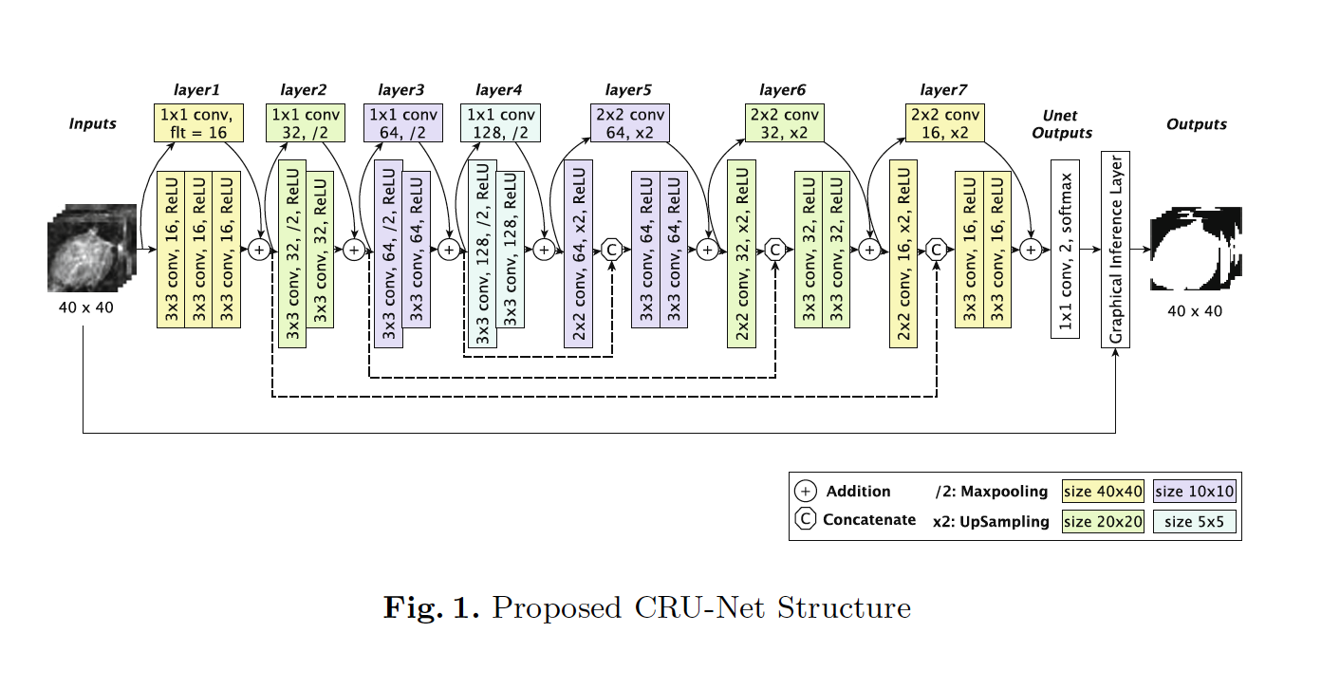

**U-Net with Residual Learning**

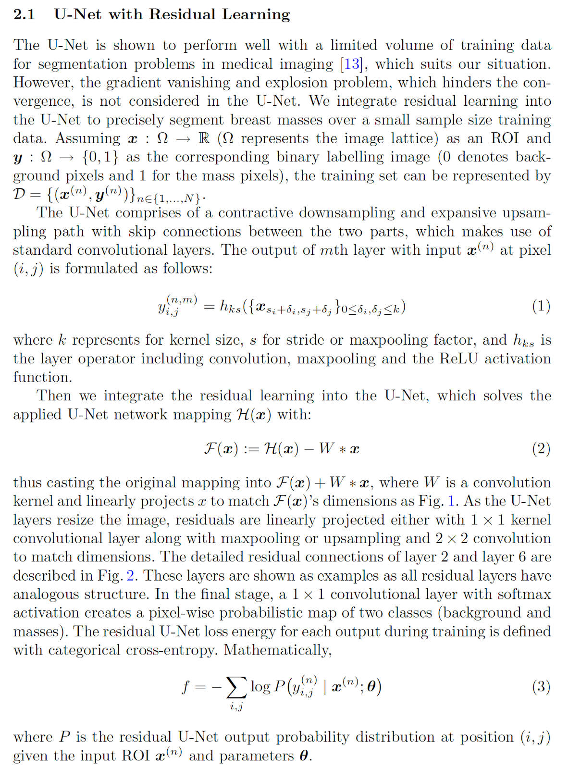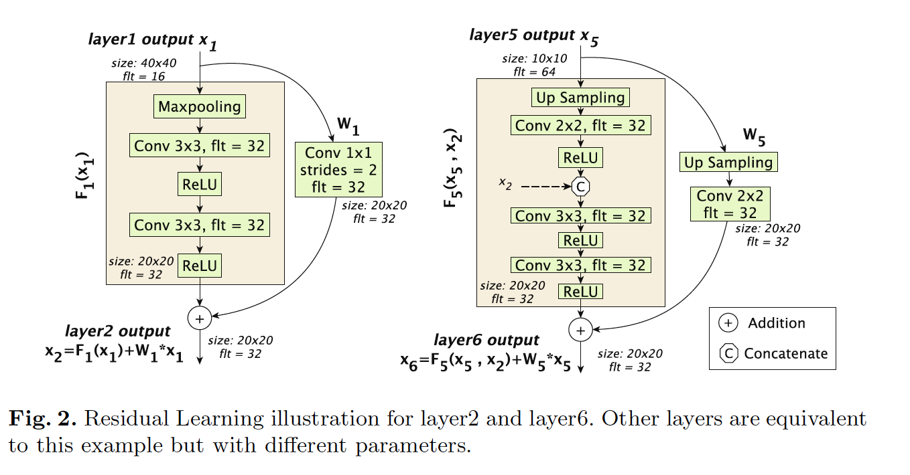

The proposed method is evaluated on two publicly available datasets **INbreast** and **DDSM-BCRP**

**In INbreast, the best Dice Index (DI) 93.66% is obtained with CRU-Net, No R (λ = 0.67) and a similar DI 93.32% is achieved by**

**its residual learning; while in DDSM-BCRP, all state-of-art algorithm performs similarly and the best DI 91.43% is obtained by CRU-Net (λ = 0). The CRU-Net performs worse on DDSM-BCRP than INbreast, which is because of its worse data quality. To better understand the dice coefficients distribution in test sets,**

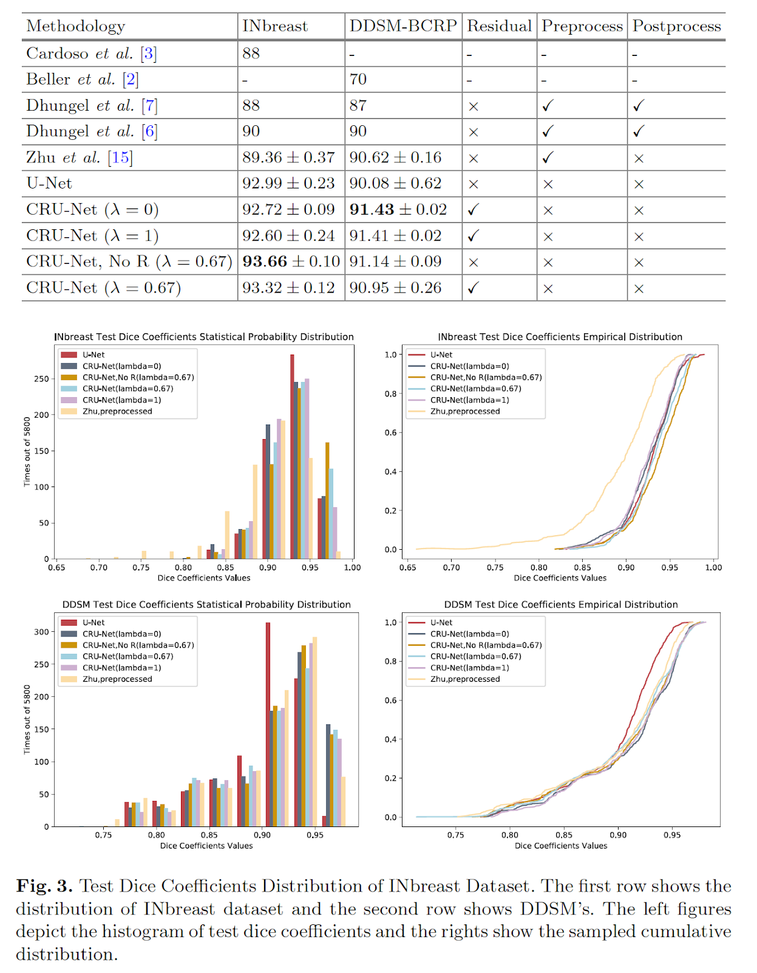

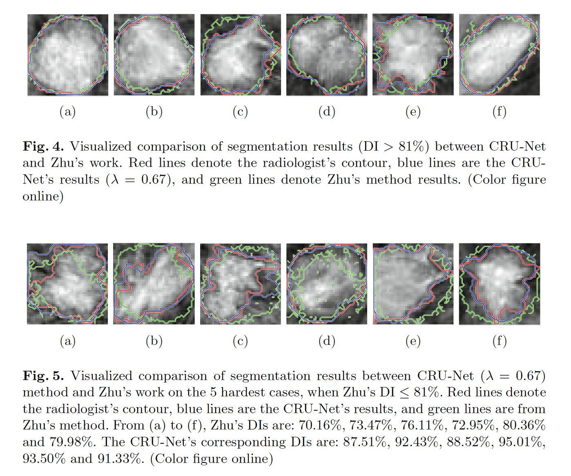

**Conclusions**

CRU-Net to improve the standard U-Net segmentation

performance via incorporating the advantages of probabilistic graphic models and deep residual learning. The CRU-Net algorithm does not require any tedious preprocessing or postprocessing techniques. It outperforms publishedstate-of-art methods on INbreast and DDSM-BCRP with best DIs as 93.66% and 91.14% respectively. In addition, it achieves higher segmentation accuracy when the applied database is of higher quality. The CRU-Net provides similar contour shapes (even for hard cases) to the radiologist with less noisy boundary, which plays a vital role in subsequent cancerous diagnosis.